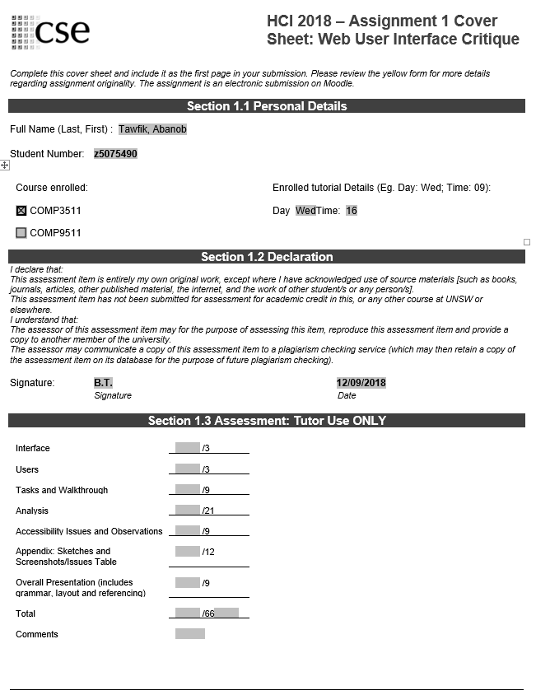

# COMP3511 Assignment 1

# Abanob Tawfik

# A critique of Planet Ark

# Wednesday 6-8pm Tutorial

# CHIL Lab k17 (CSE) G13

Table of Contents

Choice of Interface and Purpose of Interface 3

Users 3

Tasks 3

Walkthrough 4

Analysis and Critique 4

Accessibility Issues and Observations 7

References 7

Appendix 8

Issues Table 8

Screenshots 9

1A 9

1B 9

1C 9

1D 10

1E 10

2A 10

2B 11

3A 11

3B 11

# Choice of Interface and Purpose of Interface

The interface chosen for this report was the Planet Ark website. The purpose of this website is to educate users on the Planet Ark foundation and encourage users to live a sustainable lifestyle. Planet Ark is a non-profit organisation that aims to “promote sustainable resource usage, encourage a low carbon lifestyle and connect people with nature” (Planet Ark, 2018). The website contains articles, news, and information regarding the organisation’s projects and campaigns in order to encourage its users to join their cause. The Planet Ark website also aims to inform its users on partnered businesses and endorsed products that promote an environmentally friendly régime. Planet Ark implores its users to sign up to their newsletter that contains different news pieces designed to inspire people to live a greener lifestyle, and encourages users to donate to the organisation, to help expand and improve the current outlooks.

# Users

The target audience for the Planet Ark website include; financial supporters of the foundation’s campaigns; businesses that wish to collaborate with Planet Ark; individuals seeking to work with Planet Ark; people interested in living a more sustainable lifestyle; and schools. These users are drawn in by the motives of the foundation. The interface is designed to capture a general population that will be interested in a greener lifestyle.

# Tasks

Each user listed above have differing goals. Supporters of the foundation have the goal of financially supporting Planet Ark by contributing a donation. This can be done through the donate button on the menu bar. Businesses have the goal of getting their products endorsed by Planet Ark. This can be accomplished through the “working with businesses” section of the website. Individuals interested in seeking employment from the organisation have the goal of working for Planet Ark. This is achieved from the “work for Planet Ark” section. People that are interested in living a more sustainable lifestyle have the goal of educating themselves on recycling and environmentally friendly products. This can be done by signing up to the foundation’s newsletter. Schools have the goal of providing a greener environment for their students. Schools can reach this goal through the “at school” section.

# Walkthrough

The first walkthrough for this report was on the newsletter to support users attempting to live a greener lifestyle. First the user would click the signup button at the right side of the menu bar. The user would then enter their details and choose categories that they are interested in, and then click subscribe. The user then receives a confirmation that they are now subscribed to the newsletter. The second walkthrough for this report was on users interested in financially supporting the Planet Ark foundation by making donations. First the user would click on the donate button on the right side of the menu bar next to the signup button. The user would then click on the “donate now” button further down the page, which will redirect them to a payment page for a customisable donation. These two walkthroughs were chosen as the buttons to perform the tasks stand out on the menu bar in comparison to the standard formatting. The two tasks chosen were also part of the main purpose of the Planet Ark website.

# Analysis and Critique

The interface of the Planet Ark website is overall good, however there are some issues that could be resolved. In terms of visibility, which is a design principle that states how clear it is to the user where functions of the interface are located, Planet Ark makes it very clear to users where the main links are situated. The donate button and signup button are the largest buttons on the menu bar and their colour is contrasted to the rest of the menu bar as stated in item 12 of the issue table. This makes it clear to the user that those buttons have great significance and help users achieve their goals.

Planet Ark provides an excellent feedback system by informing the user on what they have done. Feedback is a design principle that “involves sending back information about what has been done and what has been accomplished” (Sharp, H., 2015). Item 18 of the issue table displays how users are given feedback on the status of their signup. Once a user has entered their details into the signup for the newsletter, a confirmation screen is shown informing the user their subscription has been added.

The lack of constraints provided to the users on the Planet Ark website are detrimental and could potentially cause some serious damage. Constraints are defined as a restriction to the user in order to prevent them from making errors. Item 1 of the issue table shows an instance where there is a lack of constraints which can lead to serious issues and must be fixed. On the donation form, the details input is not validated and users can setup fraudulent donations. The phone number provided on the form, the post code and city are not checked across with the other details provided for validity. A user is able to enter any sequence of numbers for a phone number regardless of which country chosen, the city name can be a single letter, the post code can be 1234 and the user would be provided with a tick for valid details. A possible solution would be to match the address with the city and post code, and make sure the phone number is in a valid format for the country chosen.

The Planet Ark website is mostly consistent with the exception of one of the pages. Consistency is a design principle that is defined as “having similar elements and using similar operations for achieving similar tasks” (Sharp, H., 2015). Item 14 of the issues table highlights a positive example of consistency; the interface contains the same header and footer on all the pages, making it look like the same website on each page. However, item 3 is a single exception where the redirection takes the user to a page with no header and footer, and the page itself has a completely different design to all other pages making it seem like a different website. A potential solution for this would be to add the header and footer to the page, and stick to the same design pattern.

Affordance is a design principle that refers to “the attribute of an object that allows people to know how to use it” (Sharp, H., 2015). Item 6 of the issue table highlights an example where Planet Ark uses button features to provide good affordance. When the buttons on the globe are hovered over, the icons shake and they become highlighted. This implies to the user that it should be pressed.

Efficiency is a usability goal that “allows users to complete simple tasks in a minimal number of steps” (Sharp, H., 2015). Item 4 focuses on an example of poor efficiency when a user attempts to donate. The donate button redirects the user to a different page where users have to find the additional “donate now” button amongst repetitive text. This could potentially confuse and irritate some users, as users expect to be at the donation page when they press the donate button.

Effectiveness “refers to how good a product is at what it’s supposed to do” (Sharp, H., 2015). Planet Ark allows its users to achieve their goals in a simple manner, as highlighted in item 11 of the issue table. The menu bar is clearly segregated for different users under sections such as businesses or campaigns. This allows the specific users to intuitively find their information.

Planet Ark offers a learnable interface that can be easily memorised. Learnability refers to how easy it is for users to learn how to use the system. Memorability refers to how easy it is to remember how to use the system. Both of these principles work hand in hand. Item 13 of the issue table highlights how the website is straightforward to learn, and what’s learnt is easily memorised. This is done through using simple terminology, and icons and images that relate directly to the information attempting to be communicated e.g. A rubbish bin for recycling, or a newspaper for stories and news.

In a heuristic analysis a match between the system and real world refers to communicating to users in a familiar language using words and images they can relate to. Item 14 of the issue table highlights how Planet Ark has an excellent match between the system and real world. All the buttons on the website have images that relate to their task, as stated in the above icon example.

The website follows a minimalistic design only showing relevant information, however there is a small issue with misplacement of information that takes away from the minimalistic design. As stated in item 5 of the issue table, the side search bar and social media information clutters the overall design. They are repetitions, as the menu bar contains a social section, so a potential solution would be to just remove the side section entirely.

Despite the lack of constraints on the donation form, Planet Ark implements error prevention in some aspects of the website which “prevents the problem in the first place” (Sharp, H., 2015). As mentioned in item 16 of the issue table, Planet Ark prevents users from entering an email address with an invalid format.

By providing the same menu bar which supports full navigation on the Planet Ark website, a sense of user control and freedom which is defined by (Sharp, H., 2015) as providing “support, undo and redo” in order for the user to have full control on their experience. As stated in item 15 of the issue table, the static menu bar on each page gives users access to all pages of the website regardless of where they are, allowing for error recovery.

Through the use of a minimalistic design as mentioned above, and meaningful symbols and icons, users can rely on recognition rather than recall. As stated in item 17 of the issue table, all icons used relate to the real system link, and areas of the website are clearly labelled, which allows users to rely more on intuition rather than recalling exact details.

Planet Ark lacks a help section under the website, which in turn provides a poor system of help and documentation. As stated in item 2 of the issue table, there is no FAQ section, or general documentation of “help”. The only system in place is email enquiry which is a time dependant task. This could lead to frustration for users looking for a more specific task. A solution would be to add a FAQ section to the website, and also a general help document at the footer of the website.

Overall the website design follows most of the design principles stated by (Sharp, H., 2015), however there are few aspects which require improvement for the sake of both the user and the website itself. The general user experience is fun, rewarding and helpful, teaching users in a creative and friendly manner on important topics often disregarded.

# Accessibility Issues and Observations

A group of users who may be interested in using this website would be people with vision impairment. Whilst attempting to use Microsoft narrator to traverse the website and read out what was on the screen (note this was tested on YouTube and the Microsoft website, working successfully), there were no items that could be read. The website provides poor support and accessibility for users who cannot rely on their sight and rather their hearing.

Another group of users who may be interested in using the website would be people with a motor disability. The buttons on the menu bar, in contrast to the signup/donate button and the globe buttons, are very small and could lead to difficulties in users with a mobility problem to click on the right spot. The buttons for the menu bar should be increased in size to allow for a larger clicking range.

# References

Planet Ark Environmental Foundation, 2018, Who we are, [ONLINE] Available from: <https://planetark.org/> [Accessed 01 August 2018].

Sharp, H. Preece, J. Rogers, Y., 2015, Interaction Design: Beyond Human-Computer Interaction, 4th edition [Accessed 01 August 2018].

# Appendix

## Issues Table

Table 1.[Style: Report_Table_Caption_Number]

Issues Table for Planet Ark website. Severity scale 0-4 based on how impactful

|  |  |  |  |  |  |
| --- | --- | --- | --- | --- | --- |
| Item | Principle | Issue Description | Screenshot location | Type | Severity |
| 1 | **Design Principles**  Constraints | The donation form has no logical constraints on options to make sure the details input is valid; allows invalid information to be processed. | 1E | negative | 4 |
| 2 | **Heuristics**  Help and Documentation | There is no FAQ section or help section for the website. The only option is contact through forms. | N/A | Negative | 3 |
| 3 | **Design Principles**  Consistency and Error Prevention | Under the about tab, the “2017 Annual Review” page has no menu bar and no redirection back to the main website. | 1C | Negative | 2 |
| 4 | **Usability Goal**  Efficiency | Donate feature requires you to go through an extra page before inserting details. | 2A | Negative | 2 |
| 5 | **Heuristics**  Minimalistic design and Aesthetic | The extra social media news on the side ends up taking away from the minimalistic design on the rest of the page. | 3B | Negative | 1 |
| 6 | **Design Principles**  Affordance | Buttons on the globe shake and highlight when hovered on indicating a button to be pressed. | 1A | Positive | 4 |
| 7 | **Design Principles**  Mapping | The mapping of the buttons is evenly spaced, with the correct position for home page button and signup. | 1D | Positive | 4 |
| 8 | **User Experience Goal**  Fun | The globe with icons plays an animation and the website dynamically changes when clicked on. | 1A | Positive | 4 |
| 9 | **User Experience Goal**  Helpful | The website contains articles that can help users understand how to live a more sustainable lifestyle. | N/A | Positive | 4 |
| 10 | **User Experience Goal**  Rewarding | From using the website, users learn the fundamentals of a greener lifestyle. It is a learning experience. | N/A | Positive | 4 |
| 11 | **Usability Goal**  Effectiveness | The interface is user friendly, provides information in an accessible and intuitive way. | 1A, 1B, 1D, 1F,1D | Positive | 3 |
| 12 | **Design Principles** Visibility | The signup and donate button are large and coloured. The menu bar buttons are also coloured. | 1D | Positive | 3 |
| 13 | **Usability goal**  Learnability and MemorabilityLearnability | The icons used and the terminology used is put in general terms, and navigation is made simple with obvious headings. | 1A, 1B | Positive | 3 |
| 14 | **Design Principles** Consistency | The same menu bar and footer on each page. | 1B | Positive | 3 |
| 14 | **Heuristics**  Match between the system and real world | The images used on icons and buttons match the real-world representation, e.g. rubbish bin for recycling. | 1A | Positive | 3 |
| 15 | **Heuristics**  User control and freedom | The same menu bar on each page allows users to return to a place of familiarity, the home page. | 1B | Positive | 2 |
| 16 | **Heuristics**  Error prevention | Entering an invalid email in the signup will result in a error message preventing sign up. | 3A | Positive | 1 |
| 17 | **Heuristics**  Recognition rather than recall | The website uses memorable icons and buttons to help users see what is available rather than recall. | 1A,1C,1D | Positive | 1 |
| 18 | **Design Principles and Heuristics**  Feedback | There is a confirmation page after signing up to the newsletter to inform user their form was processed. | 1F | Positive | 1 |
|  |  |  | 11 |  |  |

## Screenshots

### 1A

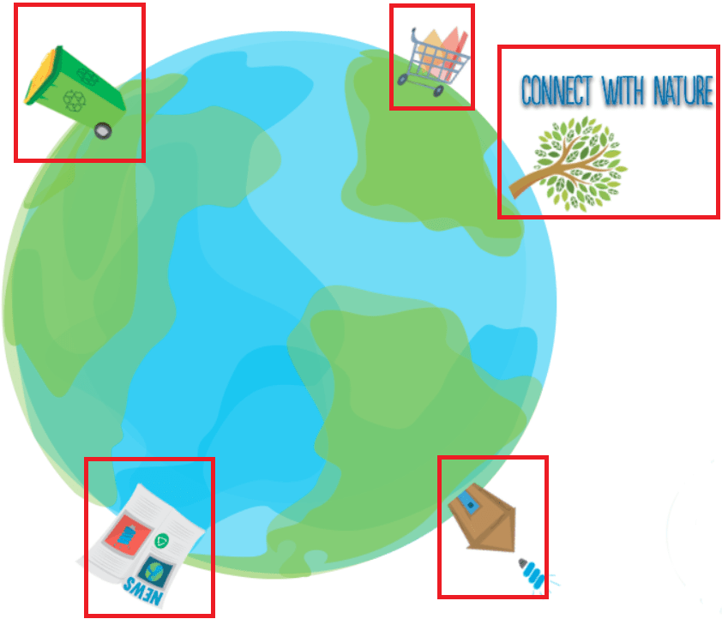

Figure 1 the globe on the home page with the buttons highlighted

### 1B

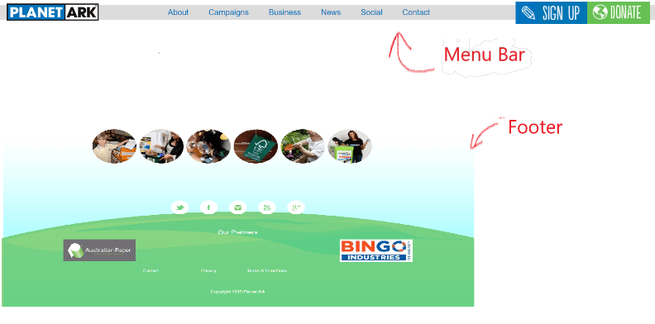

Figure 2 the menu bar and footer of the page consistent through the website

### 1C

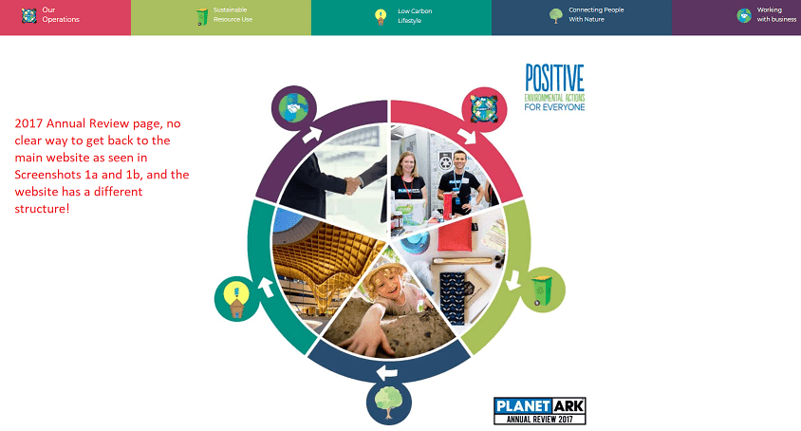

Figure 3 the redirection to the 2017 annual report through the website

### 1D



Figure 4 the menu bar on all pages with the buttons highlighted

### 1E

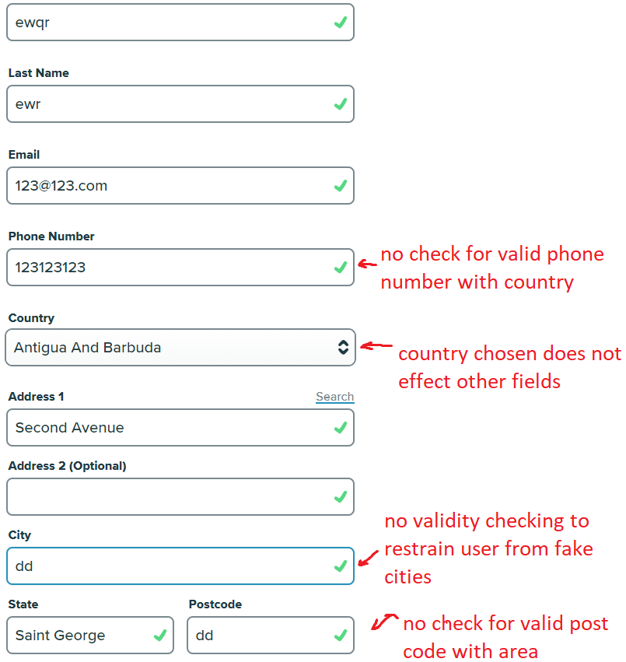

Figure 5 Attempting to make an invalid donaiton with invalid details

### 2A

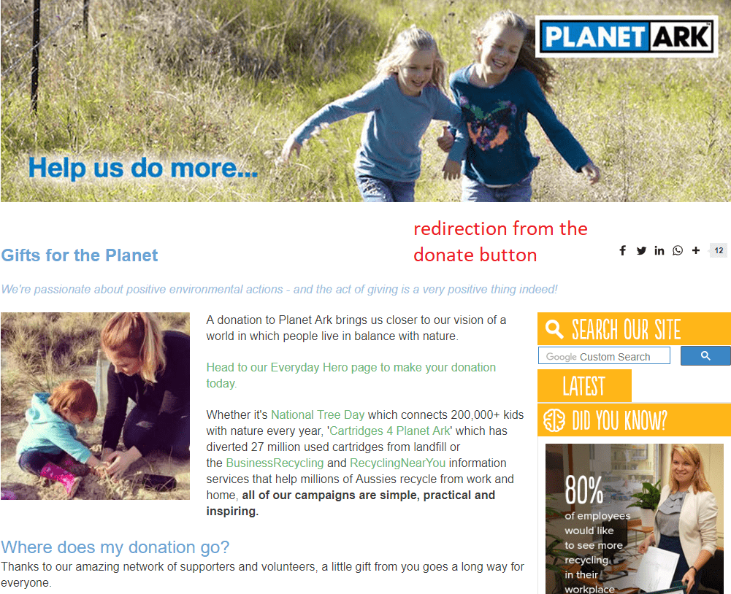

Figure 6 redirection when clicking on the donate button

### 2B



Figure 7 Confiirmation after signing up to the newsletter

### 3A

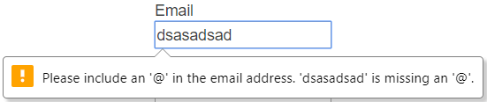

Figure 8 attempting to add an invalid email address for signup

### 3B

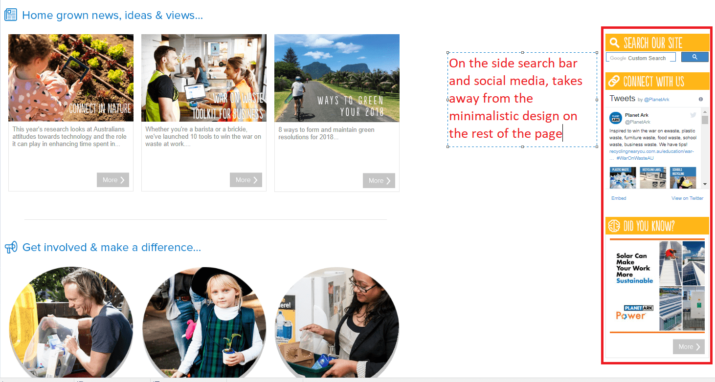

Figure 9 extra information clustered on side taking away from minimalistic design